OpenShift Software-defined Networking

OpenShift implements a software-defined network (SDN) to manage the network infrastructure of the cluster and user applications. Software-defined networking is a networking model that allows you to manage network services through the abstraction of several networking layers. It decouples the software that handles the traffic, called the control plane, and the underlying mechanisms that route the traffic, called the **data plane.**

In OpenShift Container Platform, the SDN satisfies the following five requirements:

* Managing the network traffic and network resources programmatically, so that the organization teams can decide how to expose their applications.
* Managing communication between containers that run in the same project.
* Managing communication between pods, whether they belong to a sa
* me project or run in separate projects.
* Managing network communication from a pod to a service.
* Managing network communication from an external network to a service, or from containers to external networks.m

**Some common CNI plug-ins used in OpenShift are:**

* OpenShift SDN
* OVN-Kubernetes
* Kuryr

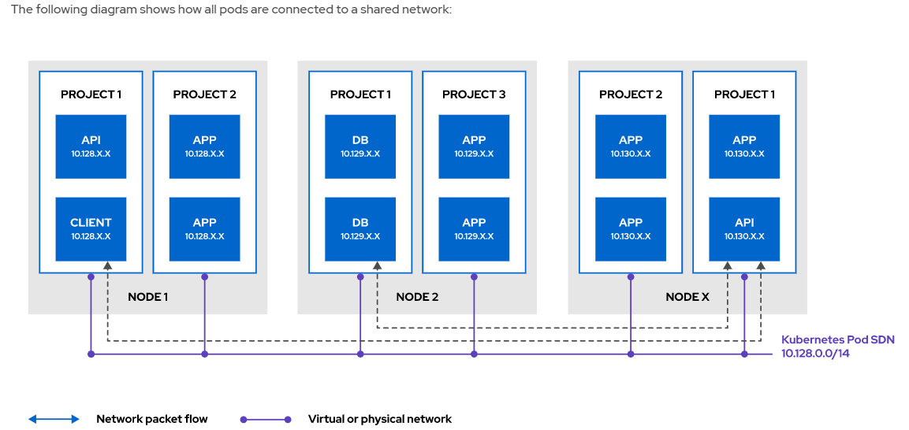

### Introducing the Cluster Network Operator:

OpenShift Container Platform uses the Cluster Network Operator for managing the SDN. This includes the network CIDR to use, the network provider, and the IP address pools. Configuration of the Cluster Network Operator is done before installation, although it is possible to migrate from the OpenShift SDN default CNI network provider to the OVN-Kubernetes network provider.

**Create the network-sdn project.**

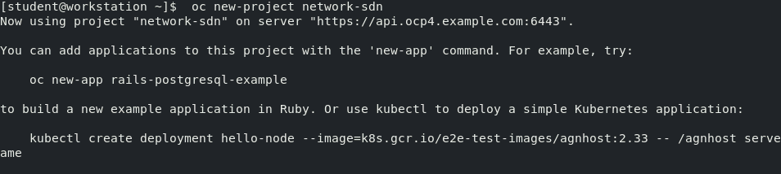

Use oc create with the -f option against todo-db.yaml to deploy the database server pod.

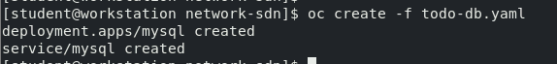

Run the oc status command to review the resources that are present in the project. The mysql service points to the database pod.

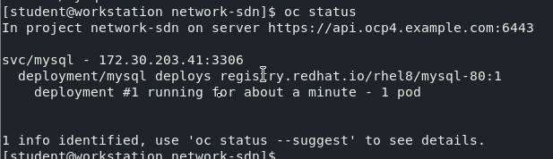

Wait a few moments to ensure that the database pod is running. Retrieve the name of the database pod to restore the tables of the items database.

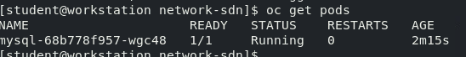

Use the oc cp command to transfer the database dump to the pod. Make sure to replace the pod name with the one you obtained in the previous step



Use the oc rsh command to connect to the pod and restore the database



